**Sprint Planning and task completion for the Project:**

**Project development guidelines:**

• The project will be delivered within four sprints with every sprint delivering a minimal viable product.

• It is mandatory to perform proper sprint planning with user stories to develop all the components of the project.

• The learner can use any technology from the above-mentioned technologies for different layers of the project.

• The web application should be responsive and should fetch or send data dynamically without hardcoded values.

• The learner must maintain the version of the application over GitHub and every new change should be sent to the repository.

• The learner must implement a CI/CD pipeline using Jenkins.

• The learner should also deploy and host the application on an AWS EC2 instance.

• The learner should also implement automation testing before the application enters the CI/CD pipeline.

• The learner should use Git branching to do basic automation testing of the application in it separately.

• The learner should make a rich frontend of the application, which is user- friendly and easy for the user to navigate through the application.

• There will be two portals in the application, namely admin and user portal.

**Admin Portal:**

It deals with all the backend data generation and product information. The admin user should be able to:

• Add or remove different genres to or from the application to build a rich product line

• Edit movie details like name, ticket price, language, description, and show timings to keep it aligned to the current prices

• Enable or disable the movie shows from the application

**User Portal:**

It deals with the user activities. The end-user should be able to:

• Sign-in to the application to maintain a record of activities

• Search for movie tickets based on the search keyword

• Apply filters and sort results based on different genres

• Add all the selected movie tickets to a cart and customize the purchase at the end

• Experience a seamless payment process

• Receive a booking summary page once the payment is complete

**Features of the application:**

1. Registration

2. Login

3. Payment gateway

4. Searching

5. Filtering

6. Sorting

7. Dynamic data

8. Responsive and compatible with different devices

**Recommended technologies:**

1. Database management: MySQL and Oracle

2. Backend logic: Java programming, NodeJS

3. Frontend development: JSP, Angular, Bootstrap, HTML/CSS, and Javascript

4. Automation and testing technologies: Selenium, Jasmine, and TestNG

5. DevOps and production technologies: Git, GitHub, Jenkins, Docker, Kubernetes, and AWS

**Pictures of Project:**

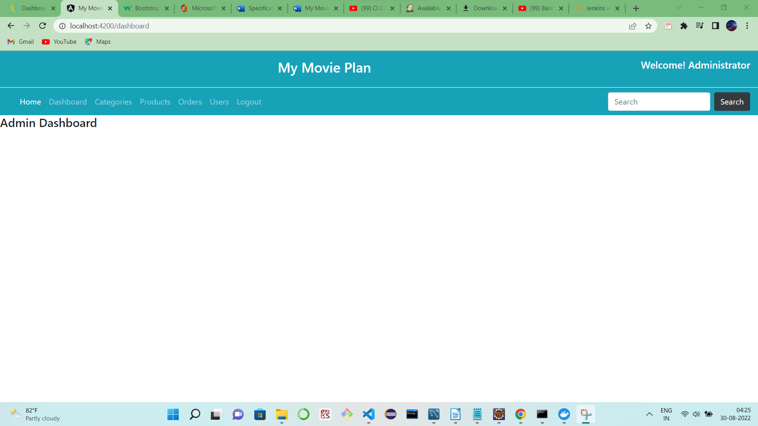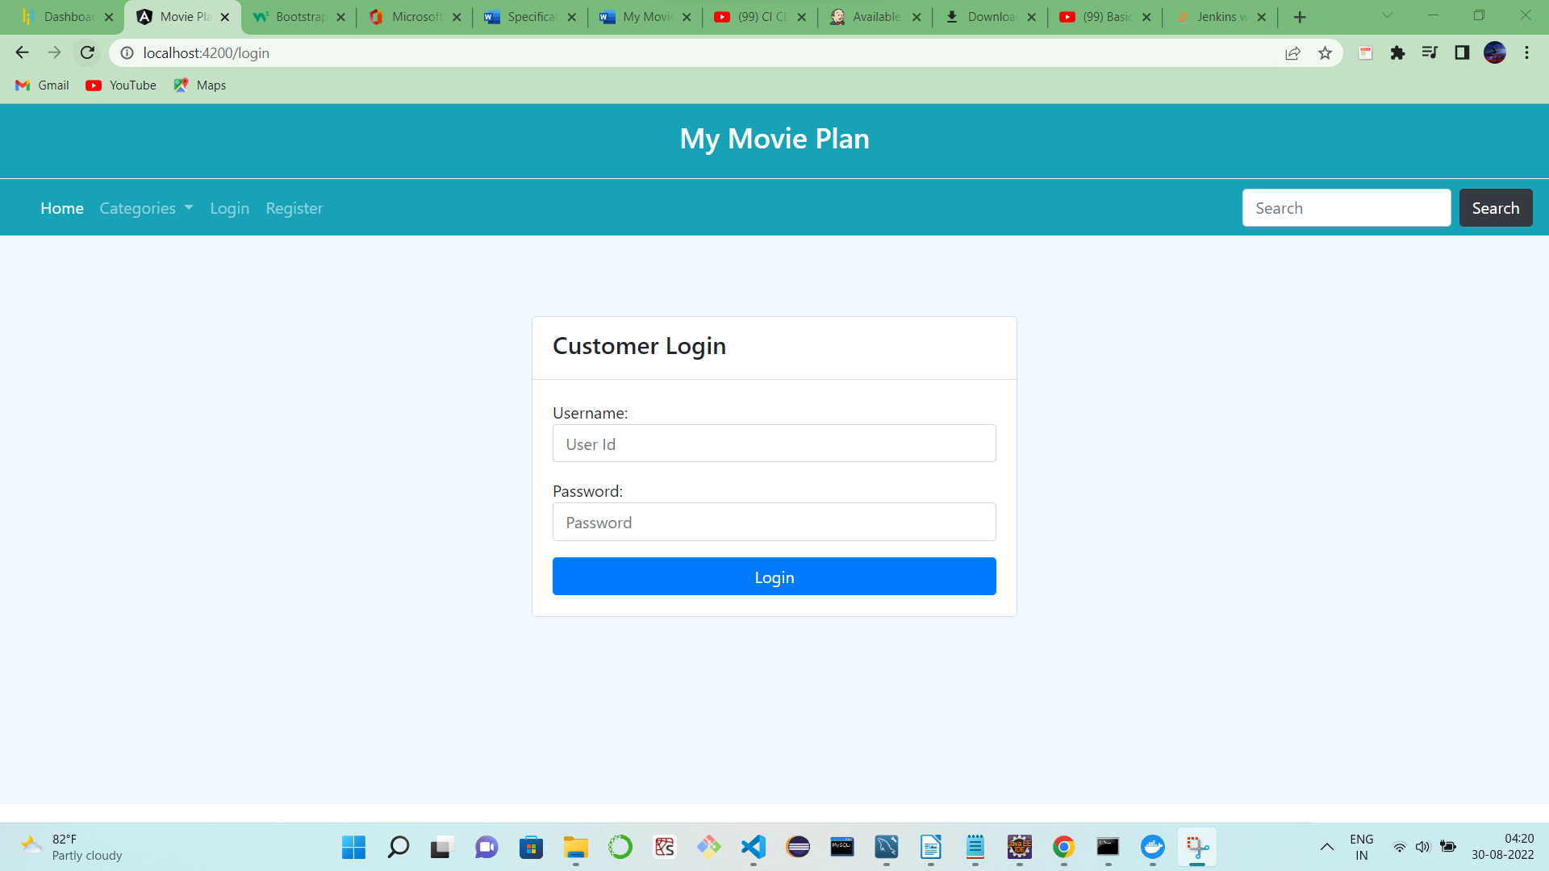

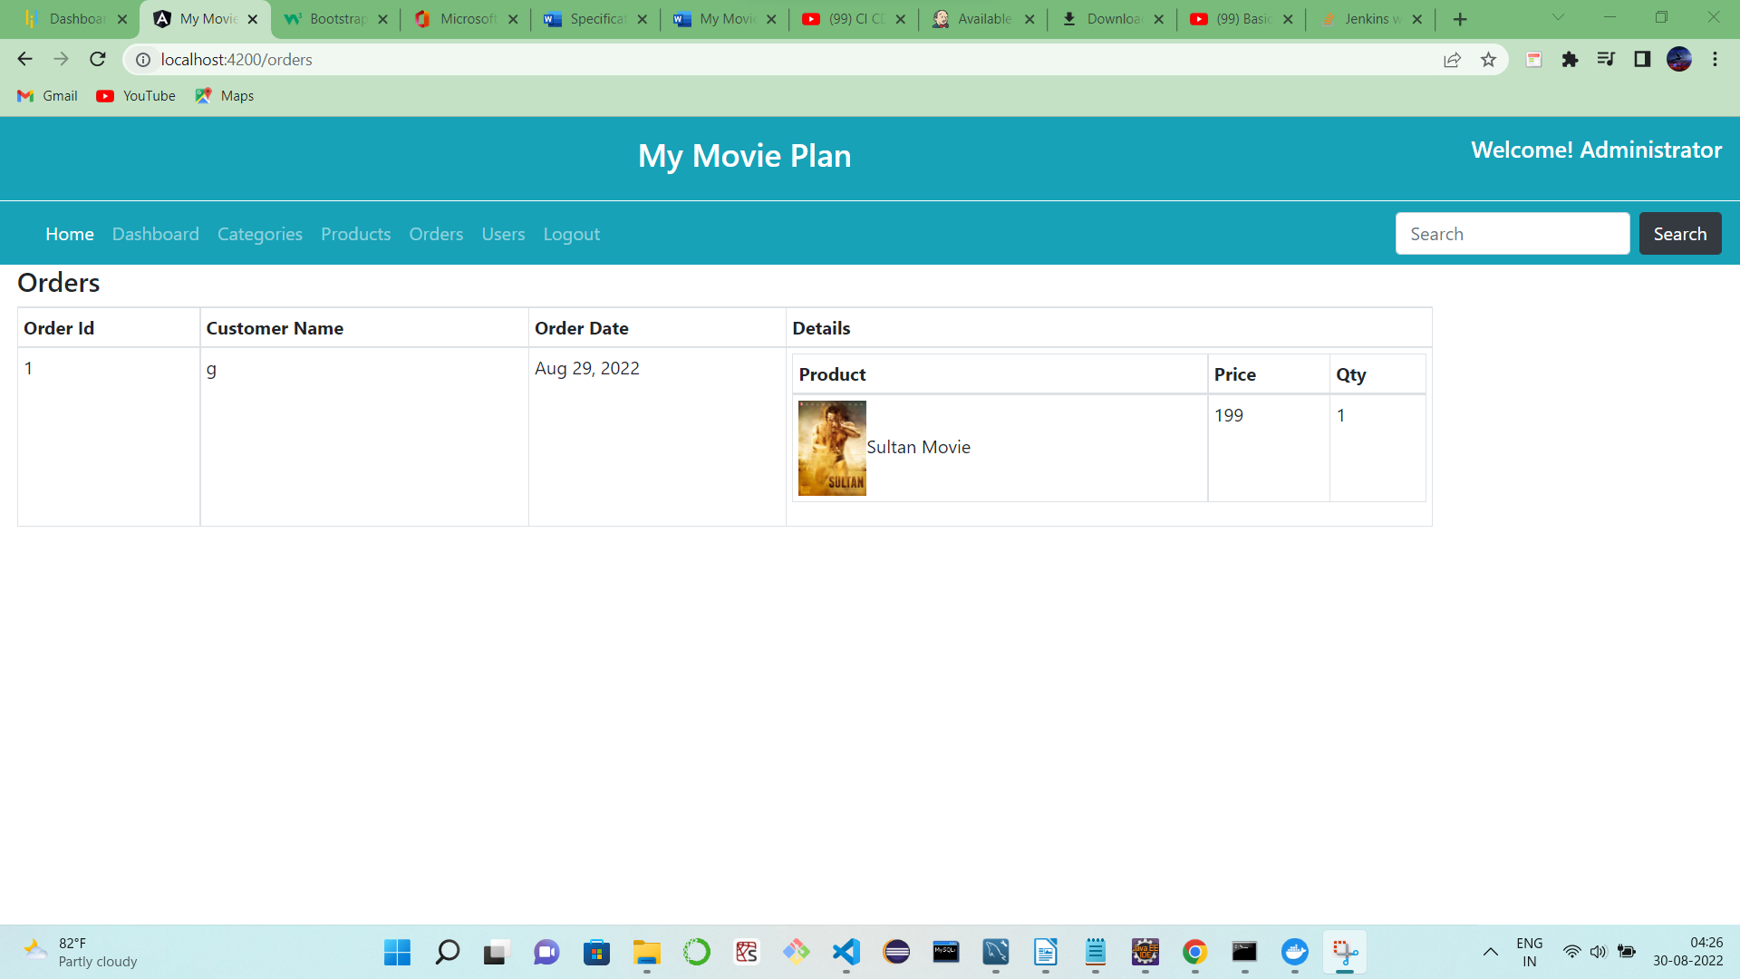

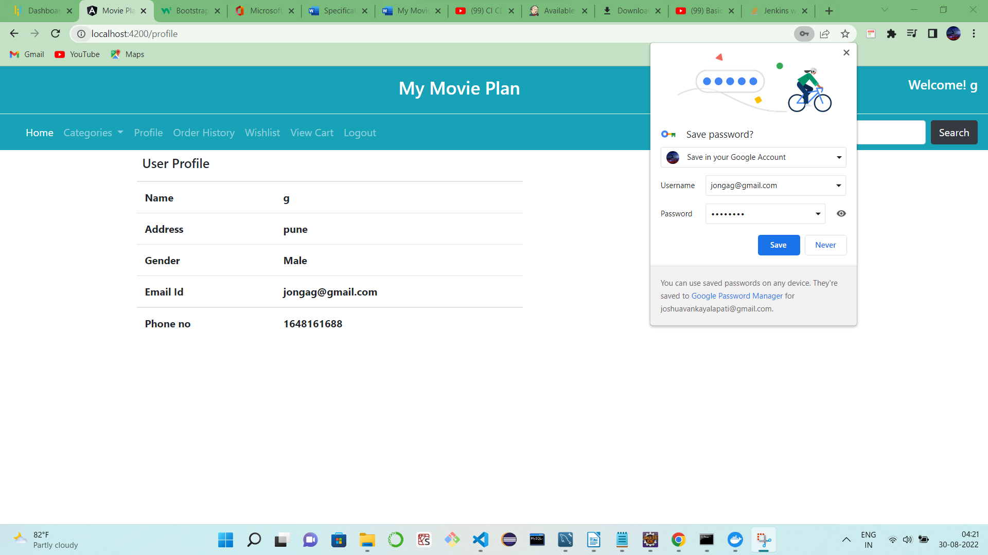

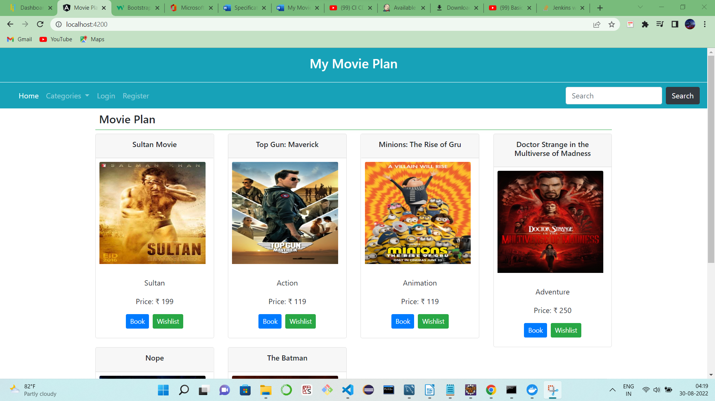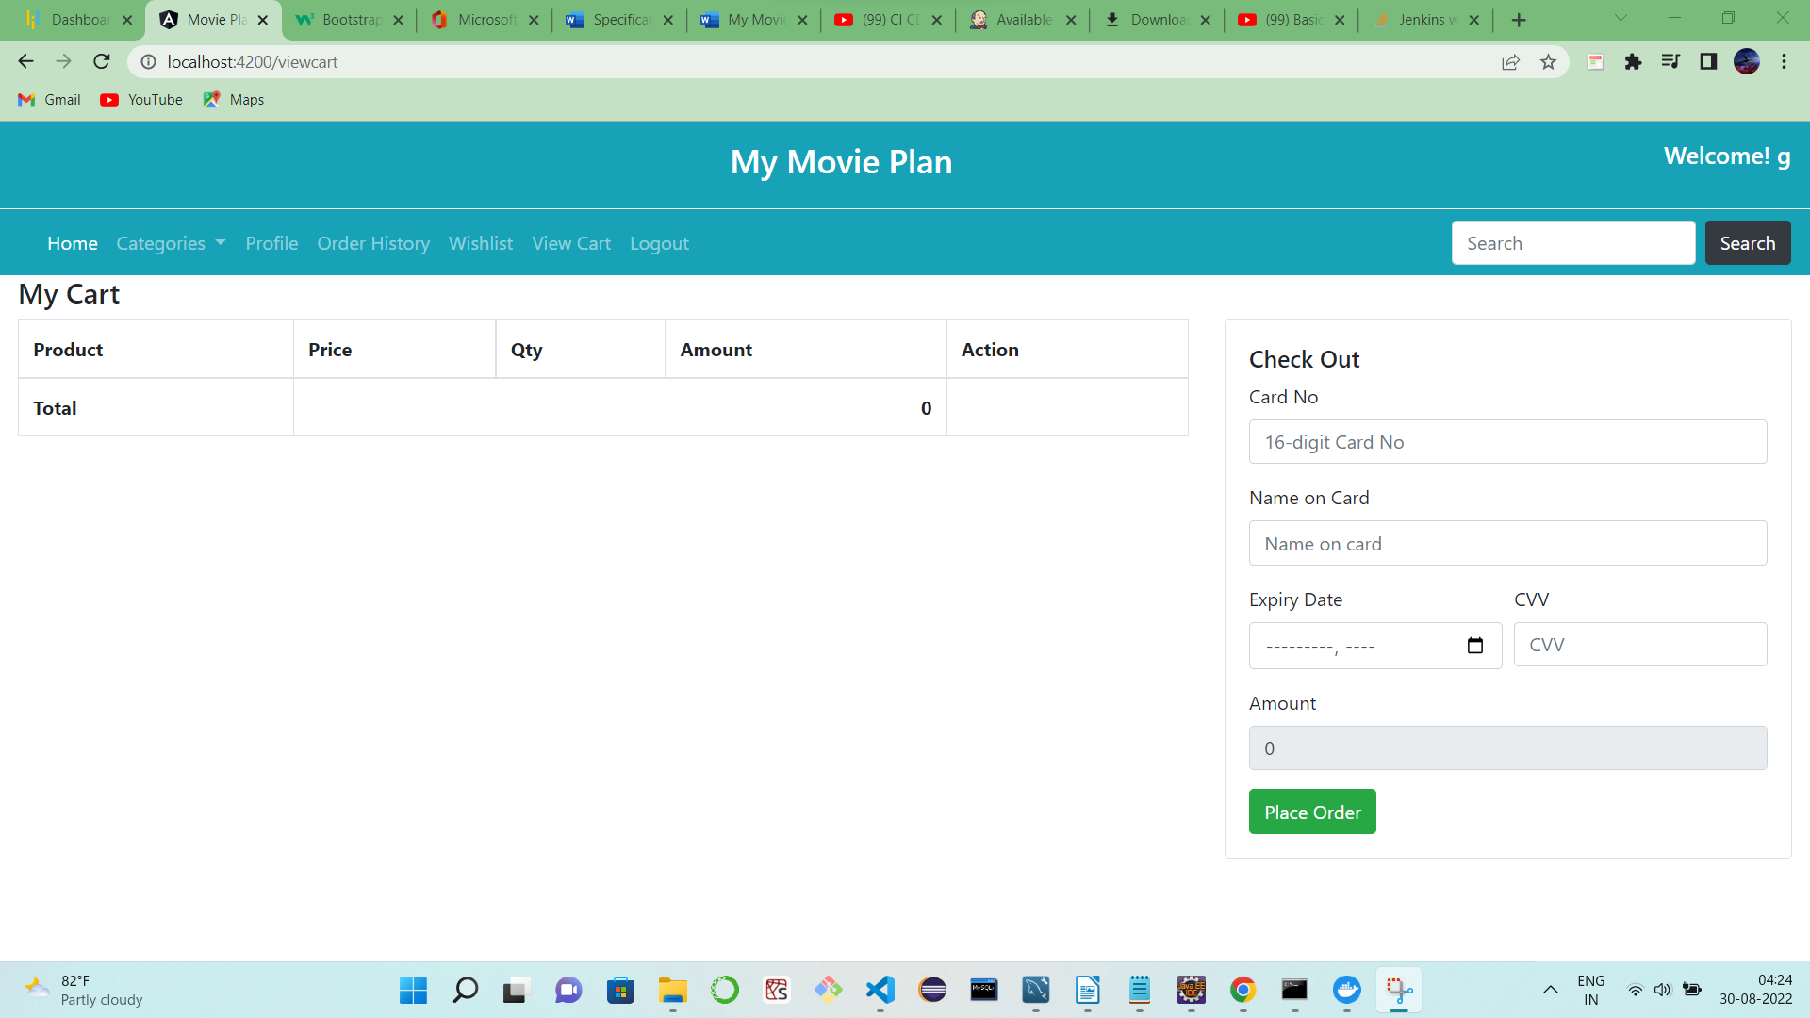

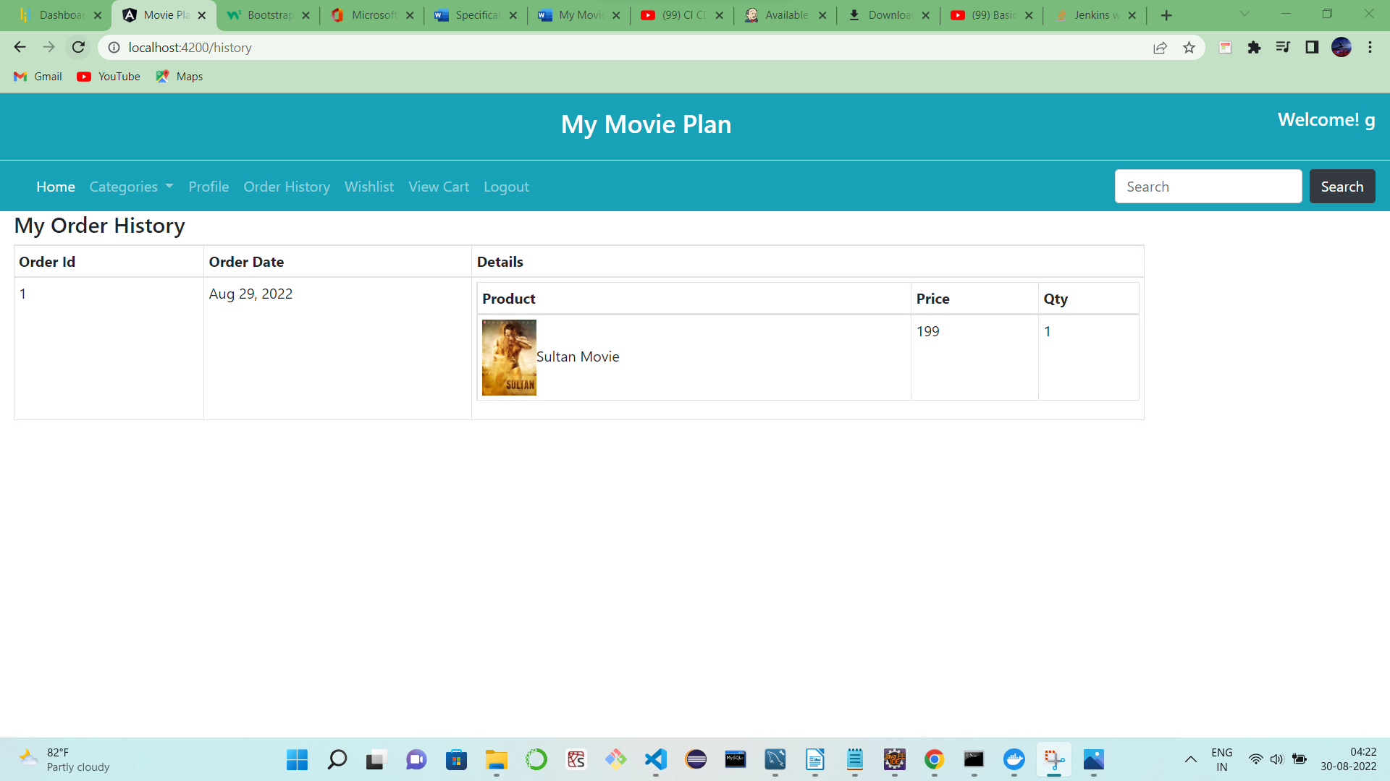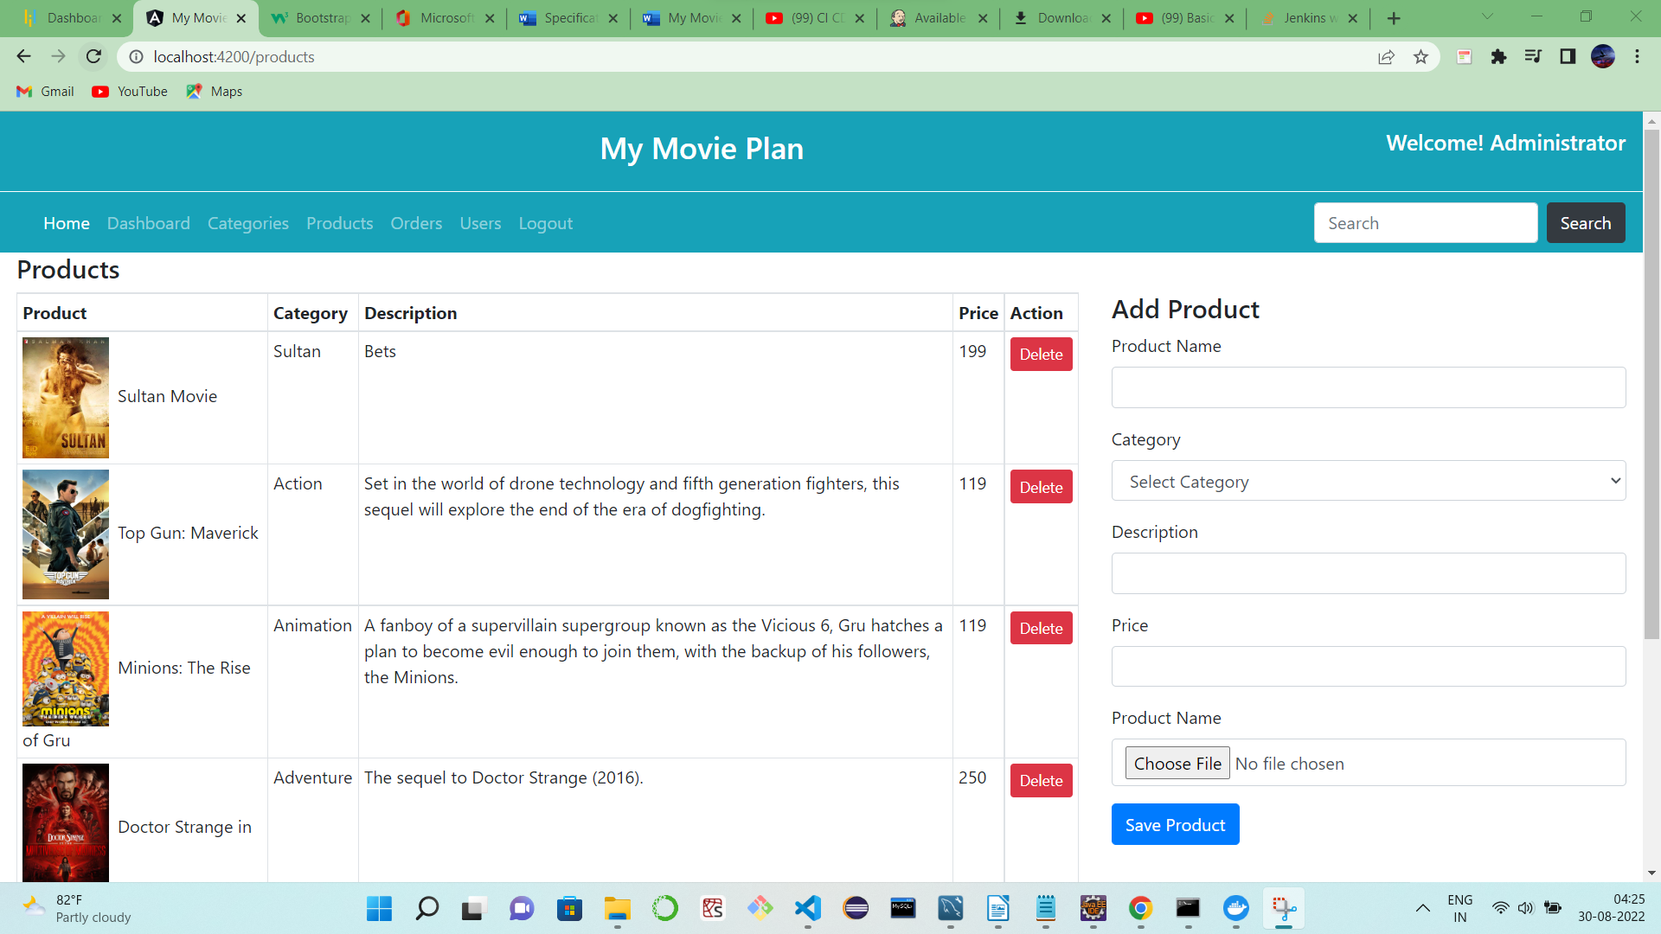

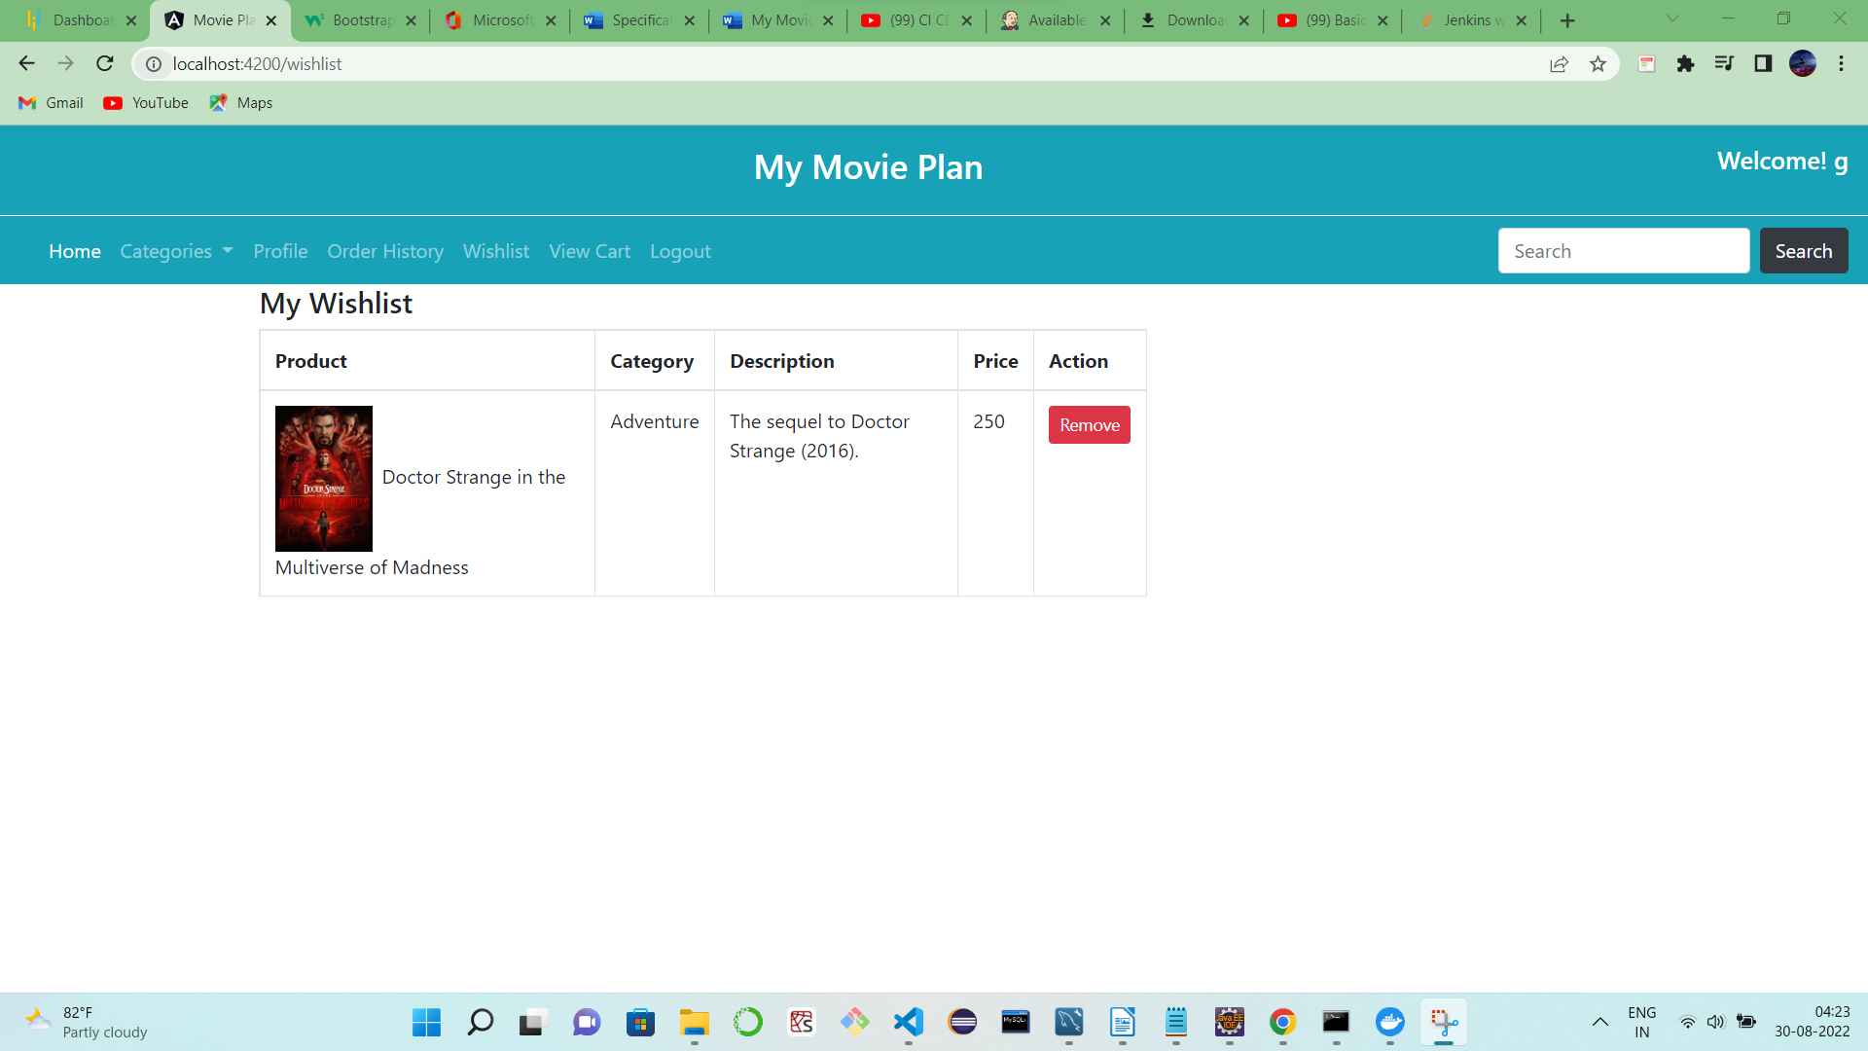

CI/CD pipeline:  
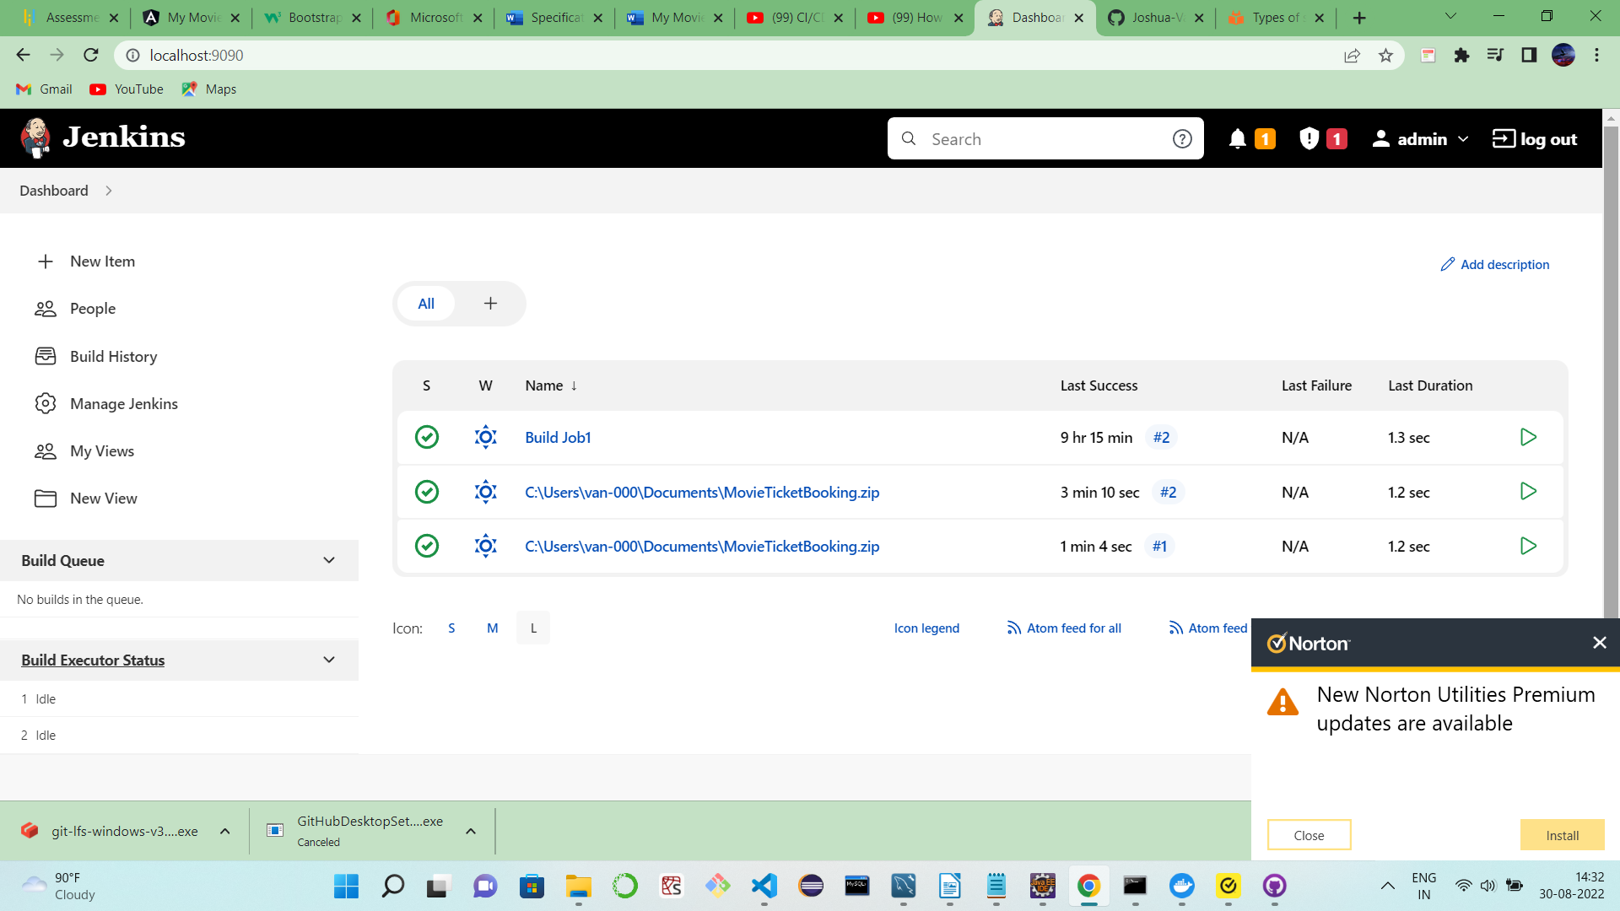

Hosting on EC2:

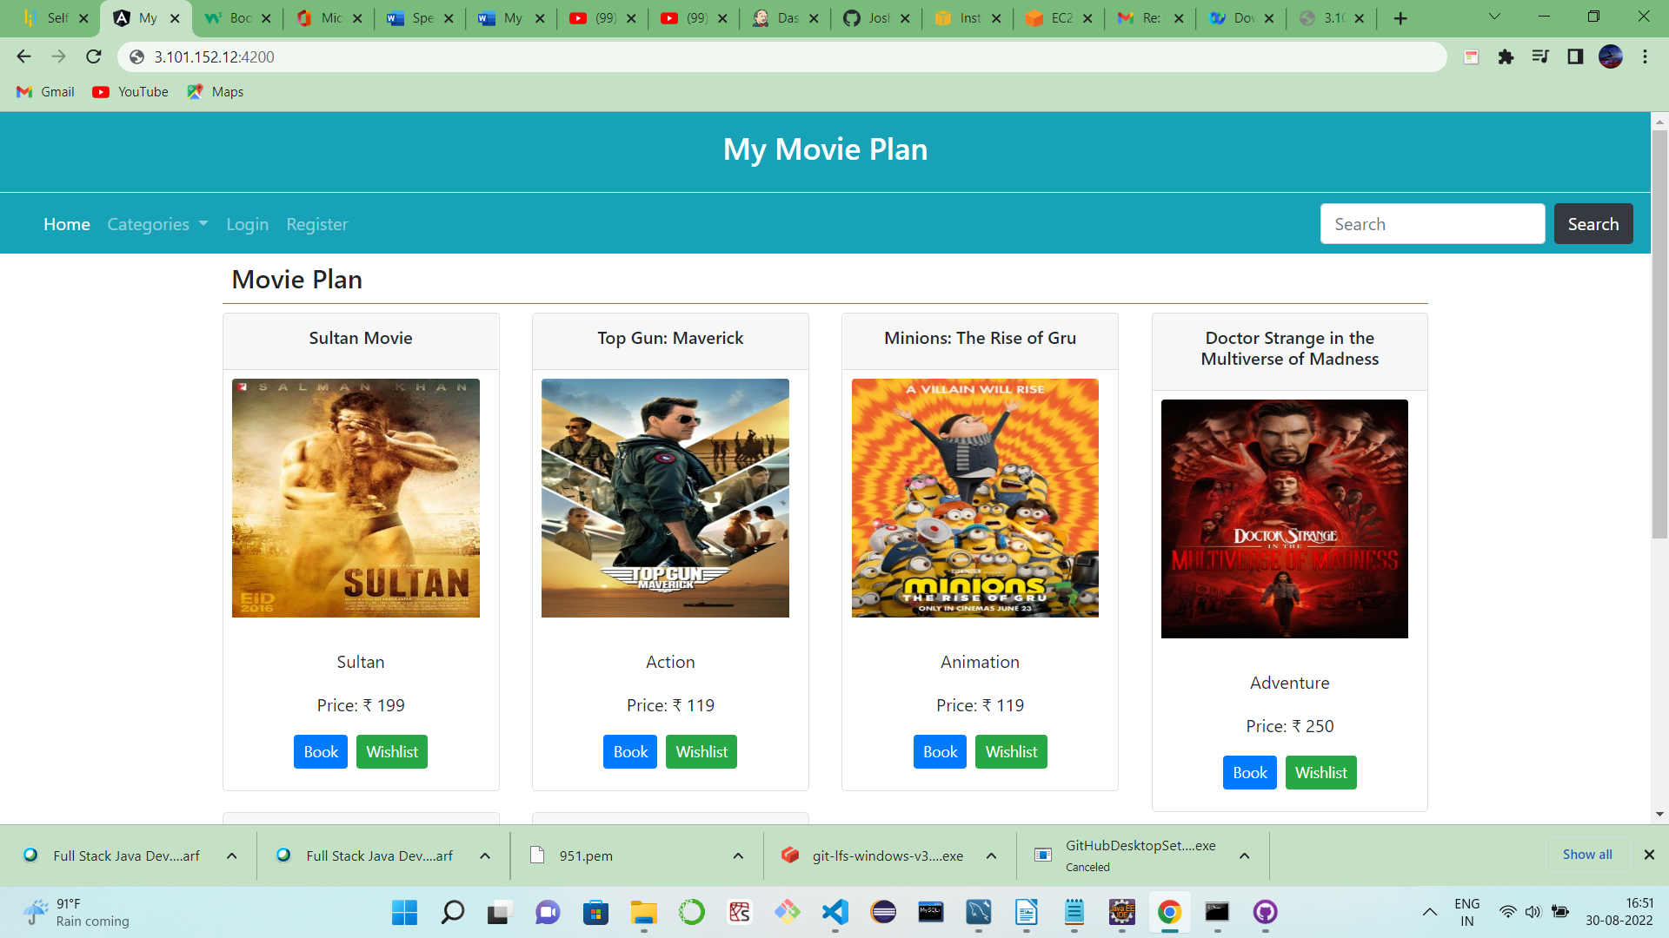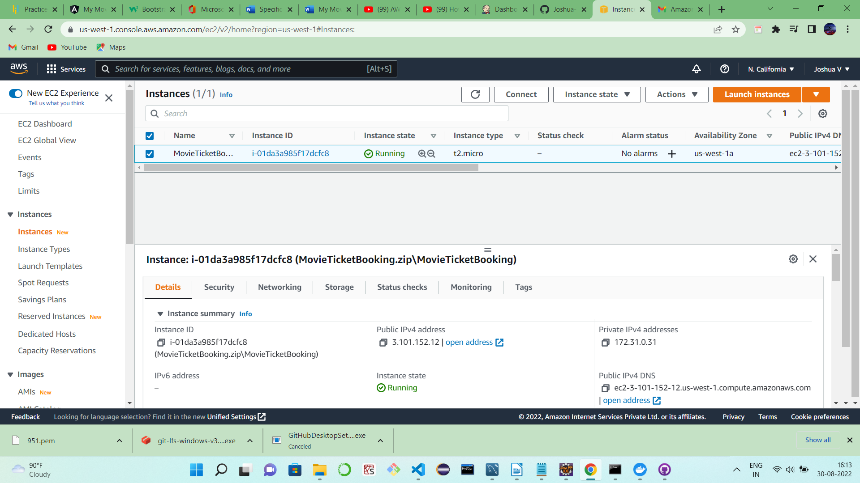

Directory properties:   
  
